AWS Task-4

Step1:

Creating the Ec2 instance with the Linux and windows Server

Screenshot mentioned Below

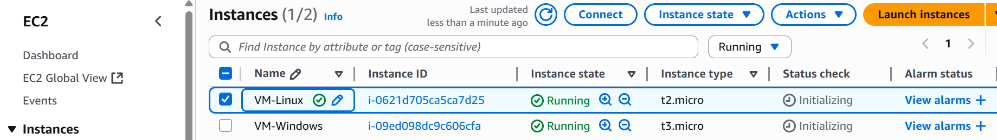

Step 2:

To create the EBS with 5GB Storage that we linked to Linux and windows so that is usage of EBS in single storage we can access through the multiple Servers

This the New Volume I created EBS



Created Volume we gonna attach to Vm-linux internal

Using df –h command to see its present or not

Actually it is not present

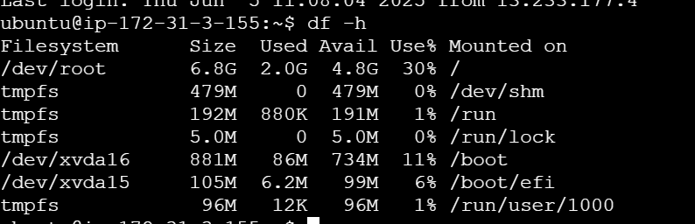

And the command using lsblk-list block that is present but have 0 disk we need to attach via command

Xvdbc is our new volume

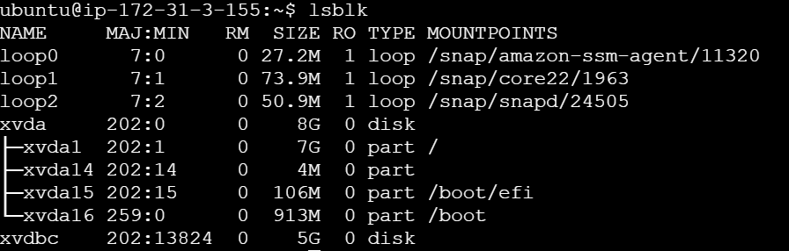

Using command we need to format

Sudo mkfs –t ext4 /dev/xvdbc

No our xvdbc is mounted to the Ec2 server using command

Screendshot mentioned Below

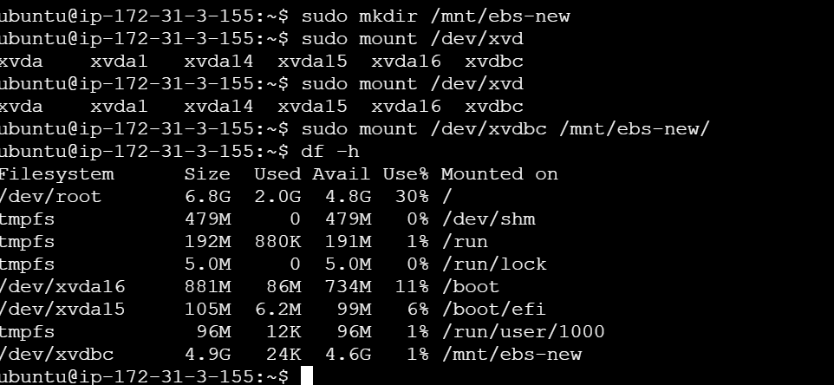

And in windows need to do the step also for that

Created snapshot of new volume

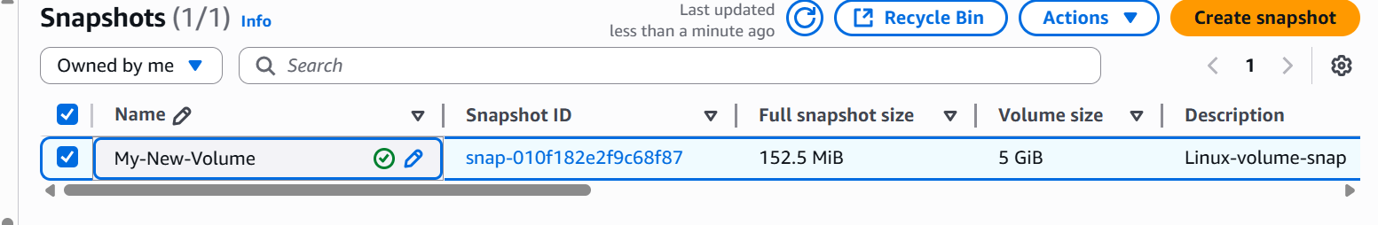

And then using this snapshot of volume I created an another volume to attach to the windows beacause same volume we cant use it in multiple server so using snapshot only it will do.

This is my already created volume I took snapshot and then I created the volume by the snapshot

And then attached to by windows server

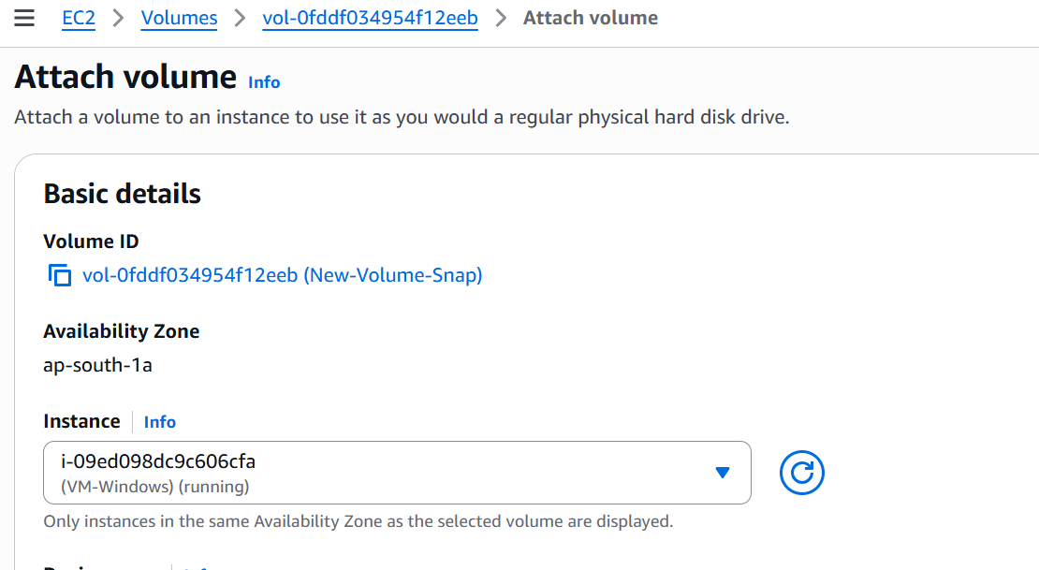

Conlusion is taking the snapshot and using into the windows also so creating one volume and using of snapshot we created copy of another volume and using in different server